71. Write a program in C to read n number of values in an array and display them in reverse order. Test Data: Input the number of elements to store in the array :3 Input 3 number of elements in the array: element - 0 : 2 element - 1 : 5 element - 2 : 7 Expected Output : The values store into the array are : 2 5 7 The values store into the array in reverse are : 7 5 2.

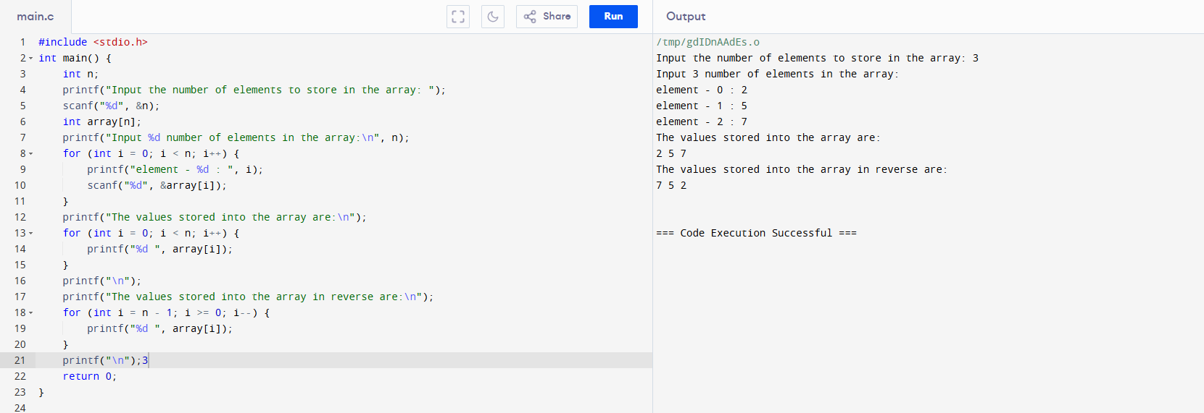

72. Write a program in C to create and display a Singly Linked List. Test Data : Input the number of nodes : 3 Input data for node 1 : 5 Input data for node 2 : 6 Input data for node 3 : 7 Expected Output : Data entered in the list : Data = 5 Data = 6 Data = 7.

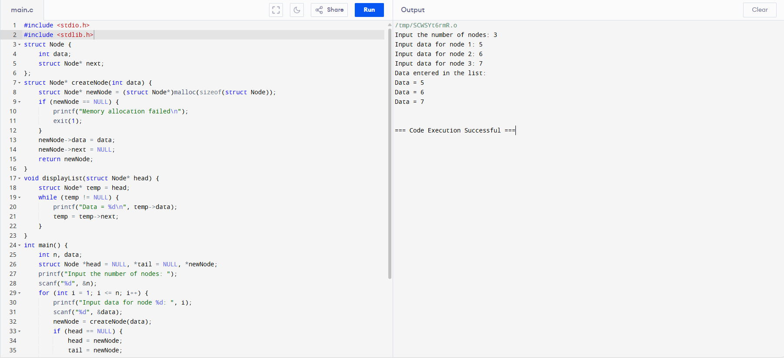

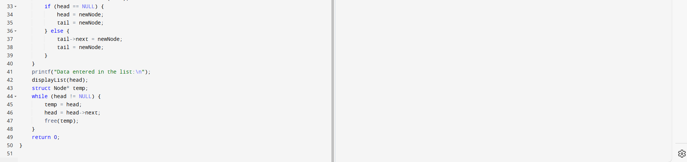

73. Write a program in C to copy the elements of one array into another array. Test Data : Input the number of elements to be stored in the array :3 Input 3 elements in the array : element - 0 : 15 element - 1 : 10 element - 2 : 12 Expected Output : The elements stored in the first array are : 15 10 12 The elements copied into the second array are : 15 10 12.

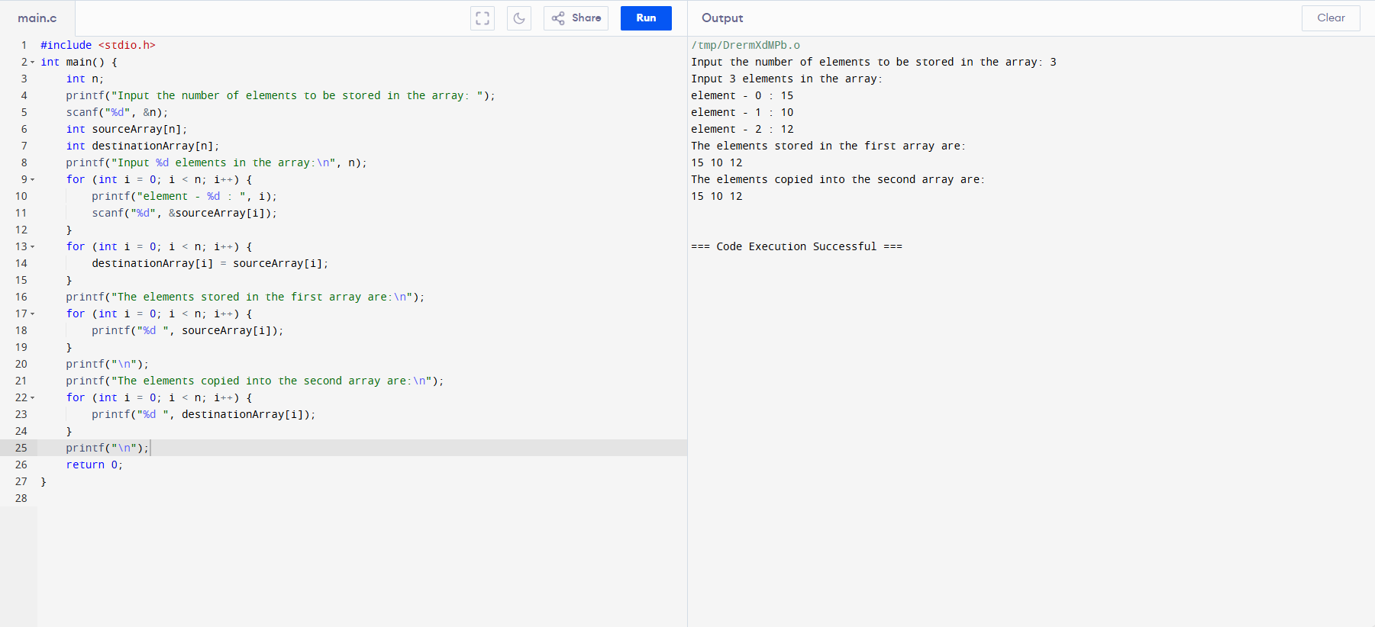

74. Write a program in C to create a singly linked list of n nodes and display it in reverse order. Test Data : Input the number of nodes : 3 Input data for node 1 : 5 Input data for node 2 : 6 Input data for node 3 : 7 Expected Output : Data entered in the list are : Data = 5 Data = 6 Data = 7 The list in reverse are : Data = 7 Data = 6 Data = 5.

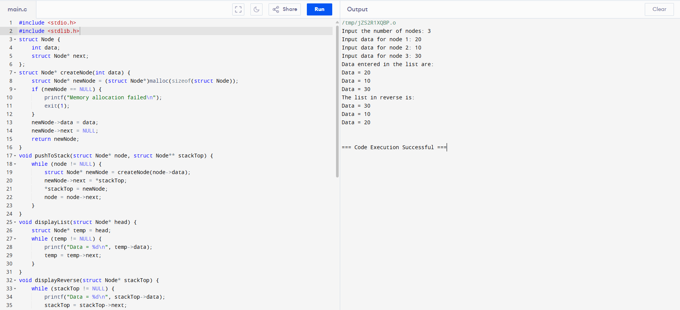

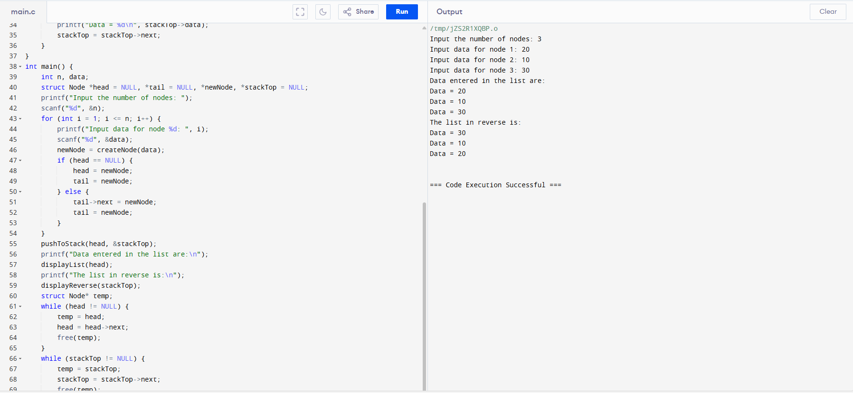

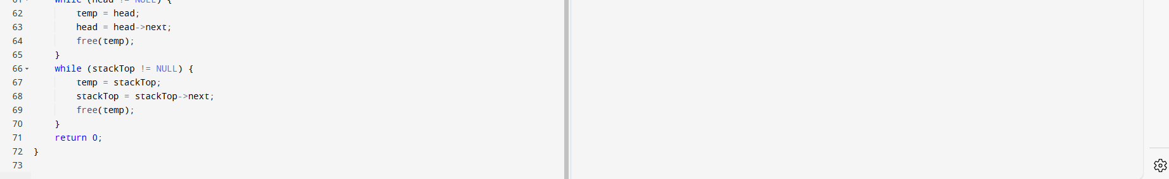

75. Write a program in C to print all unique elements in an array. Test Data : Print all unique elements of an array: ------------------------------------------ Input the number of elements to be stored in the array: 4 Input 4 elements in the array : element - 0 : 3 element - 1 : 2 element - 2 : 2 element - 3 : 5 Expected Output : The unique elements found in the array are: 3 5.

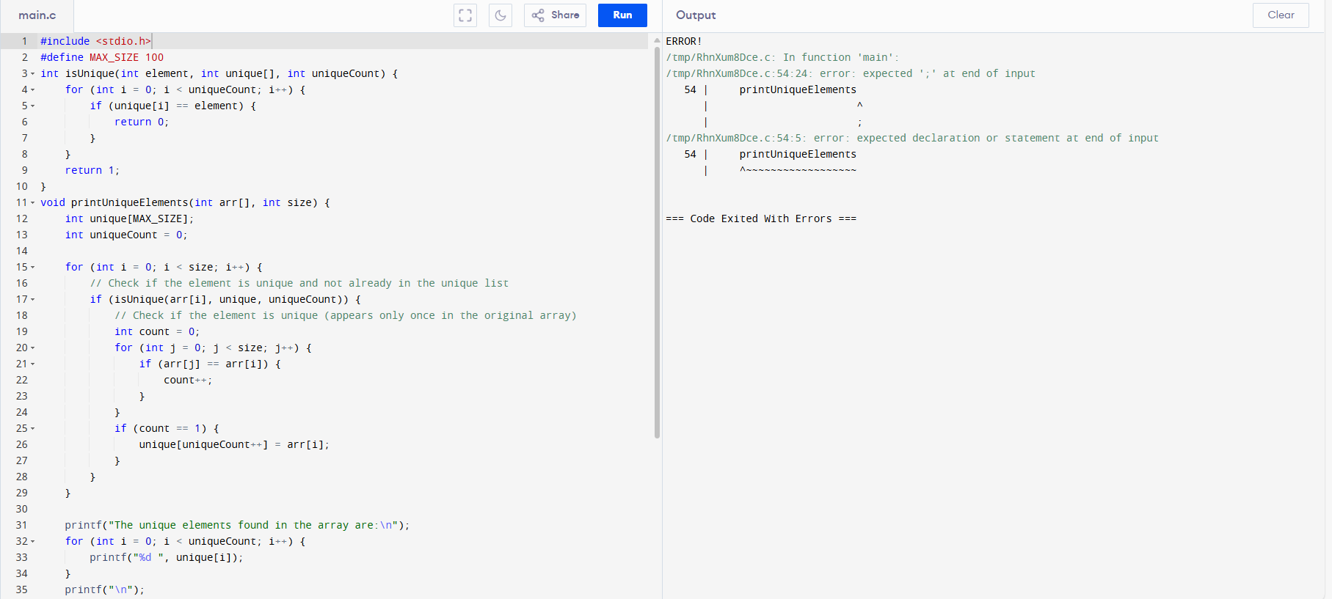

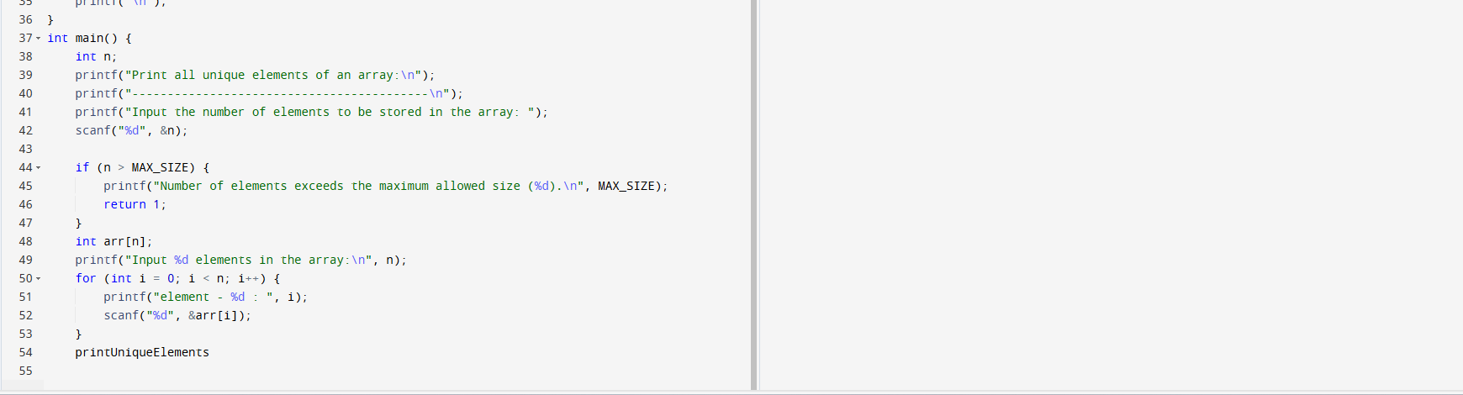

76. . Write a program in C to insert a new node at the beginning of a Singly Linked List. Test Data and Expected Output : Input the number of nodes : 3 Input data for node 1 : 5 Input data for node 2 : 6 Input data for node 3 : 7 Data entered in the list are : Data = 5 Data = 6 Data = 7.

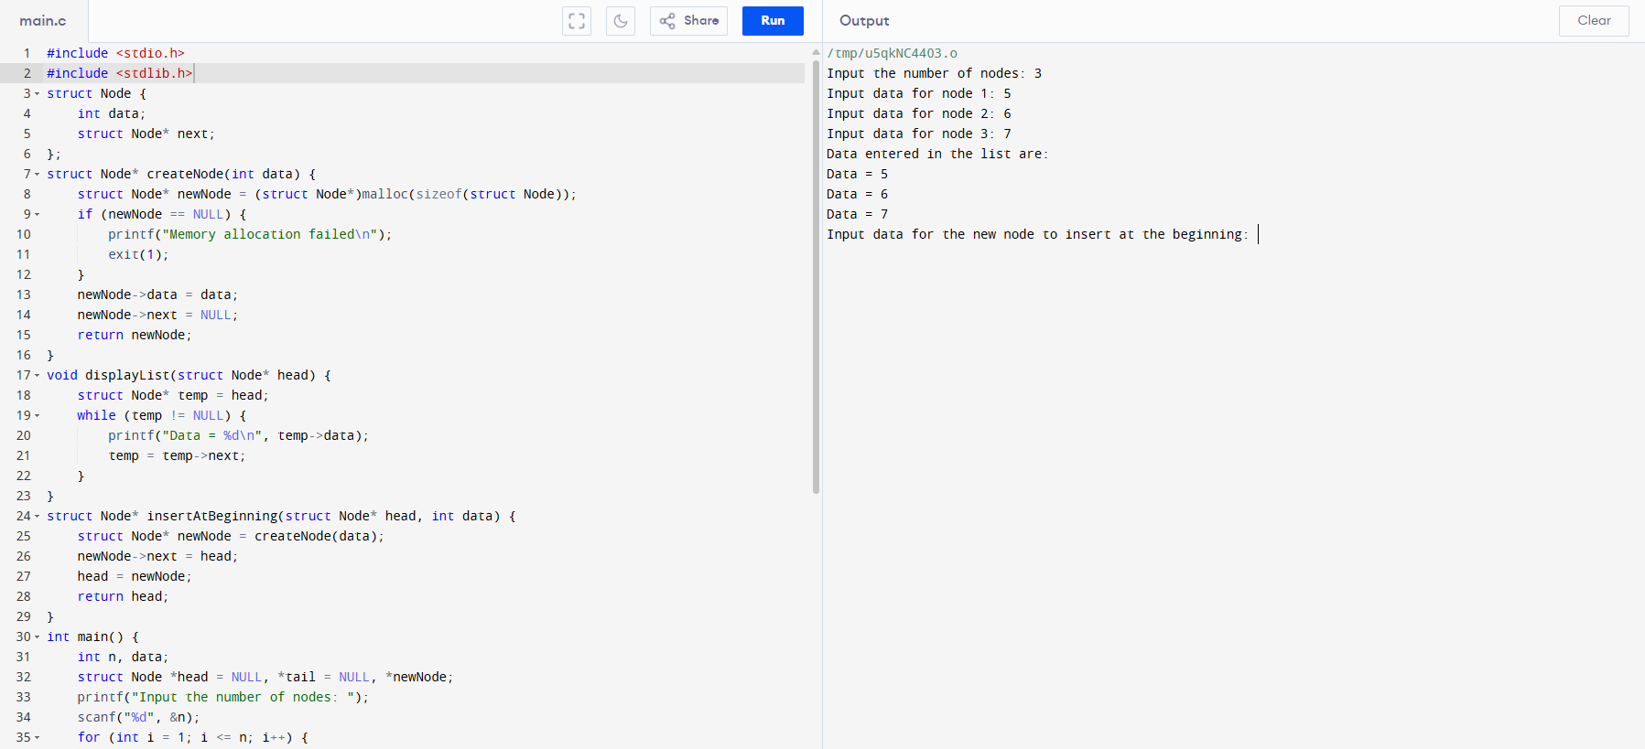

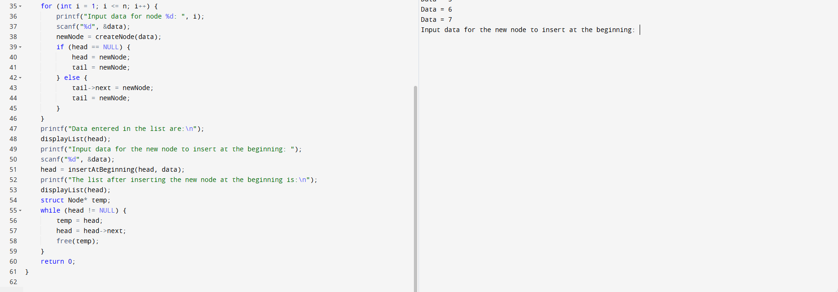

77. Write a program in C to merge two arrays of the same size sorted in descending order. Test Data : Input the number of elements to be stored in the first array :3 Input 3 elements in the array : element - 0 : 1 element - 1 : 2 element - 2 : 3 Input the number of elements to be stored in the second array :3 Input 3 elements in the array : element - 0 : 1 element - 1 : 2 element - 2 : 3 Expected Output : The merged array in descending order is : 3 3 2 2 1 1.

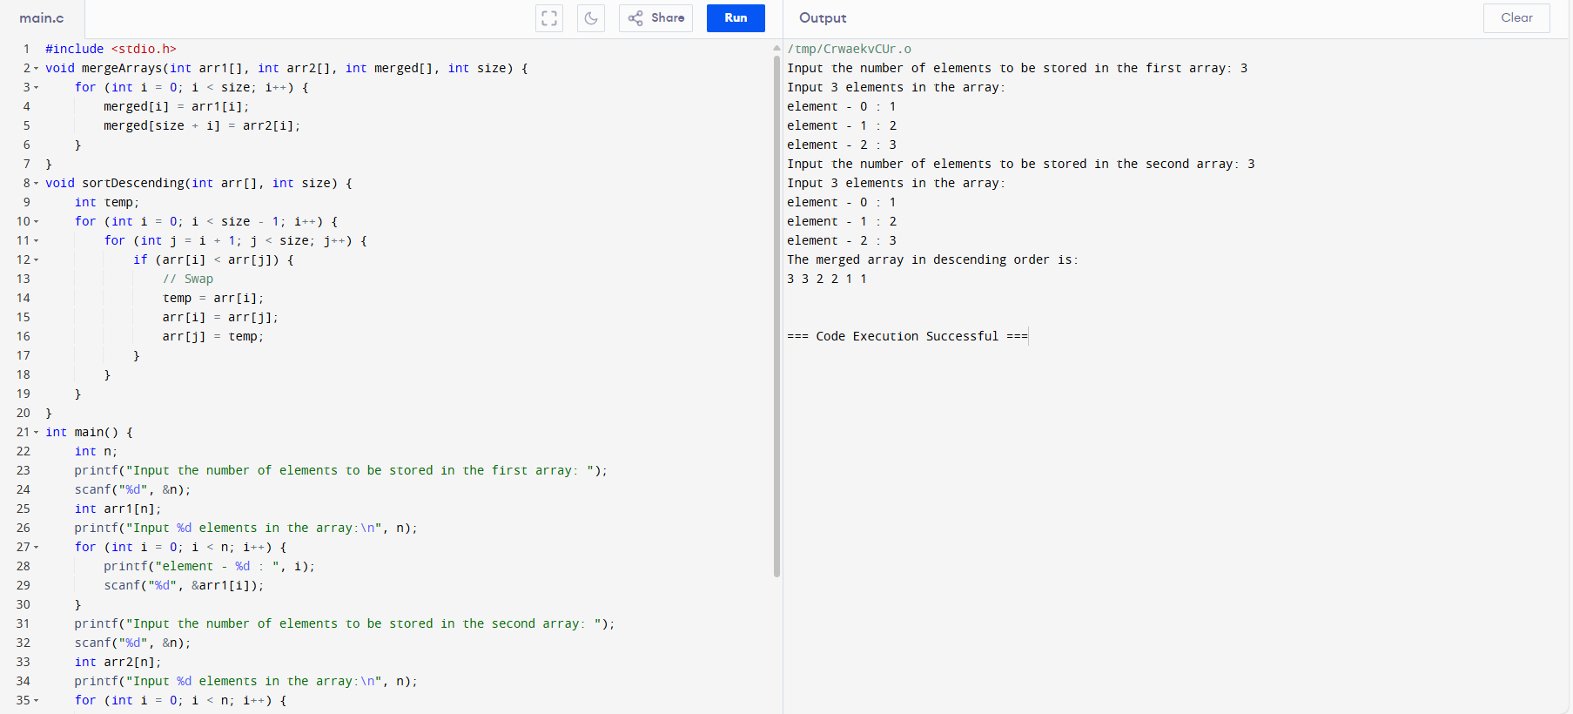

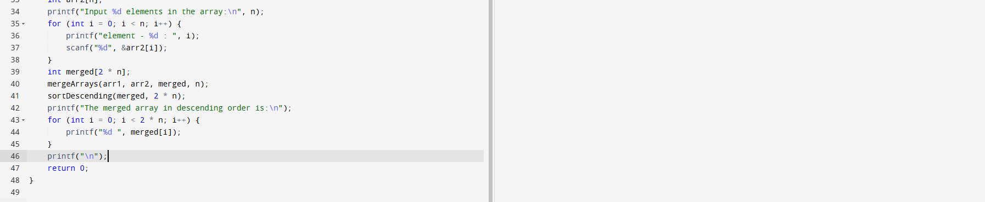

78. Write a program in C to delete a node from the middle of a Singly Linked List. Test Data and Expected Output : Input the number of nodes : 3 Input data for node 1 : 2 Input data for node 2 : 5 Input data for node 3 : 8 Data entered in the list are : Data = 2 Data = 5 Data = 8 Input the position of node to delete : 2 Deletion completed successfully. The new list are : Data = 2.

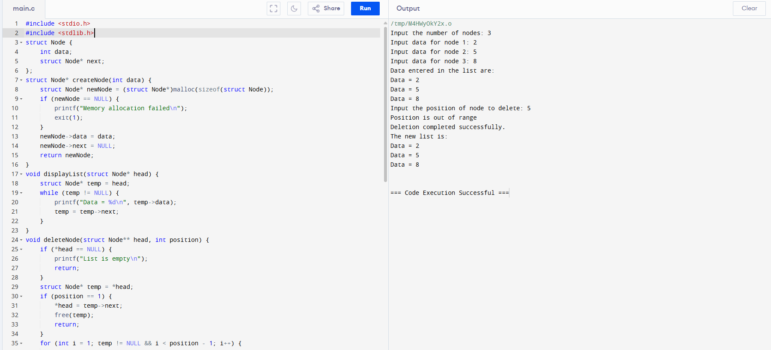

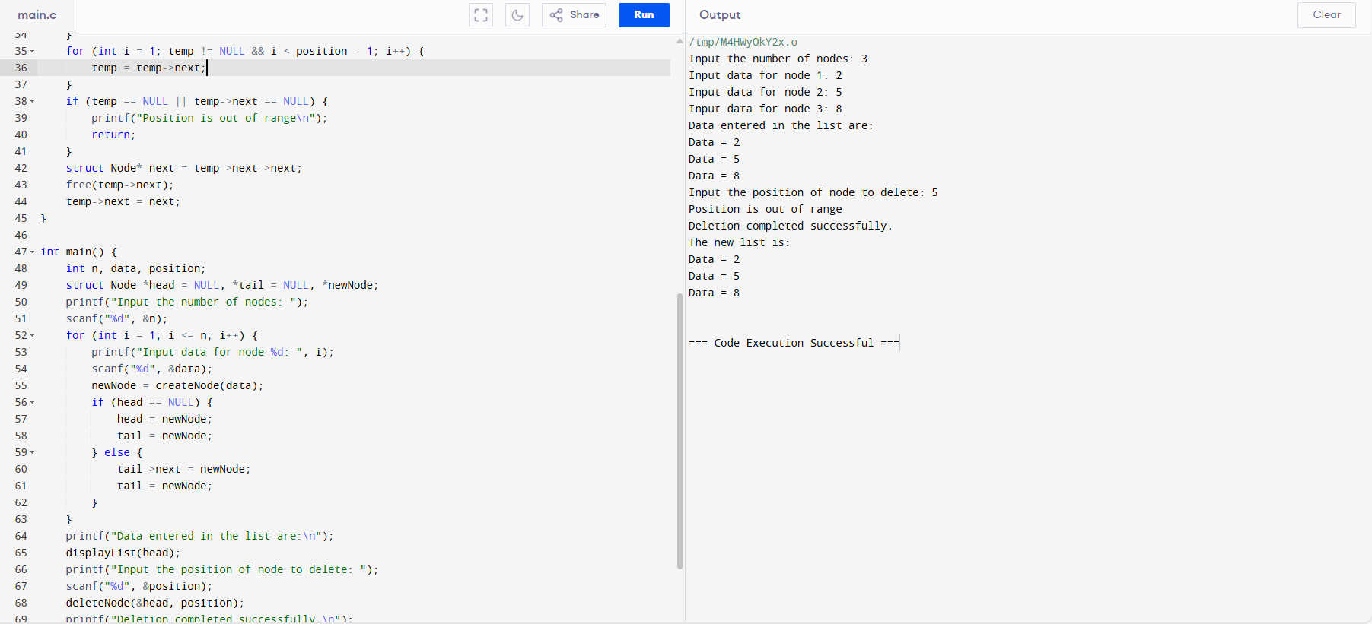

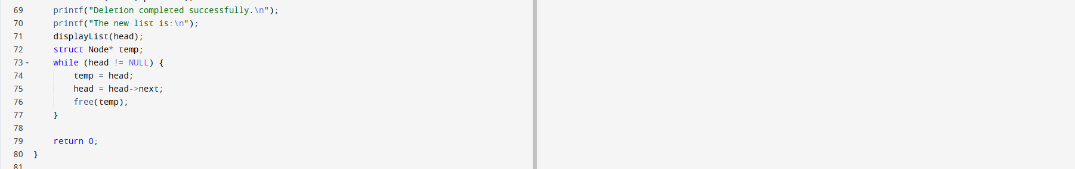

79. Write a program in C to count the frequency of each element of an array. Test Data : Input the number of elements to be stored in the array :3 Input 3 elements in the array : element - 0 : 25 element - 1 : 12 element - 2 : 43 Expected Output : The frequency of all elements of an array : 25 occurs 1 times 12 occurs 1 times 43 occurs 1 times.

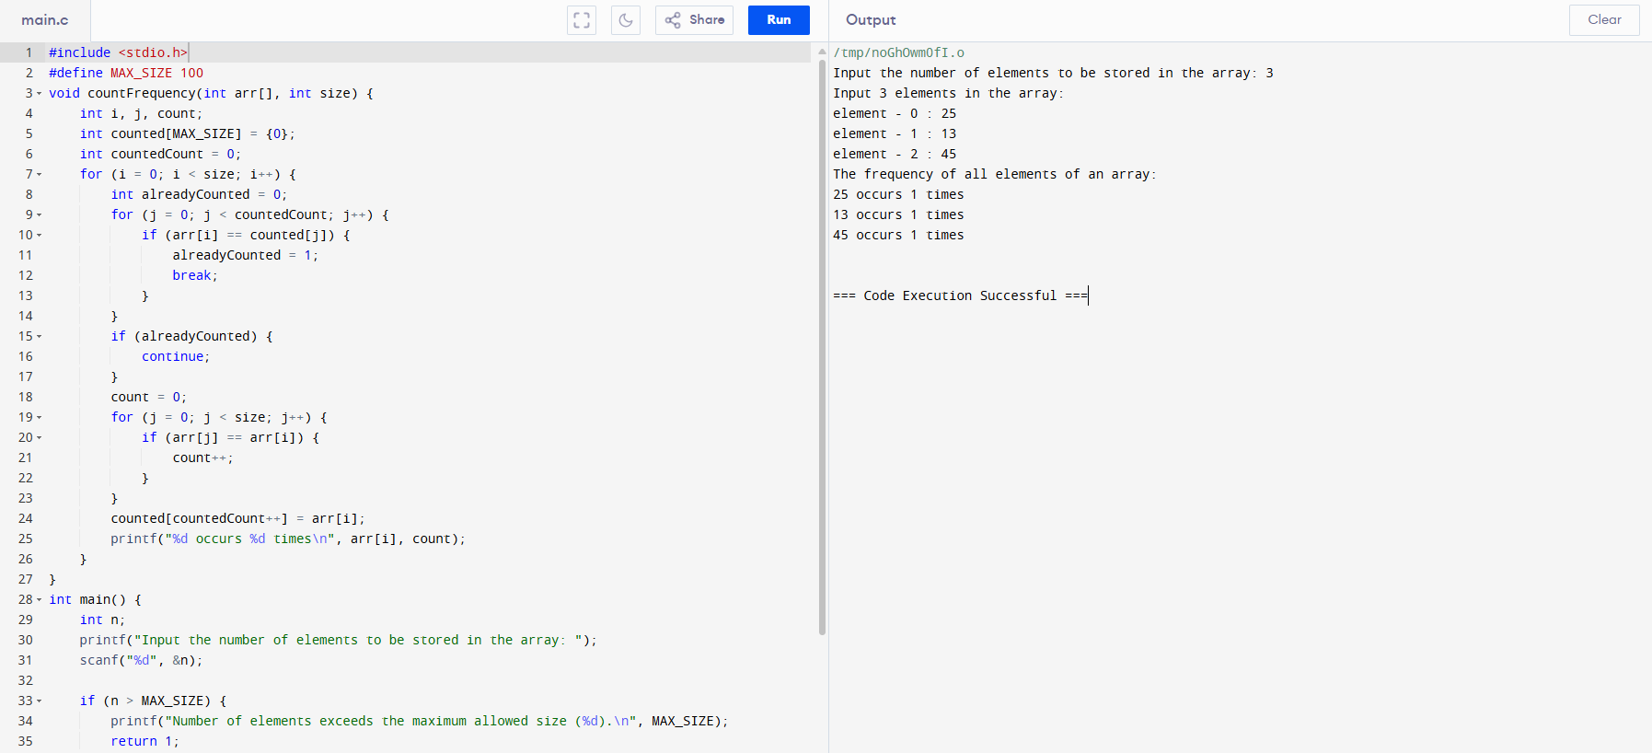

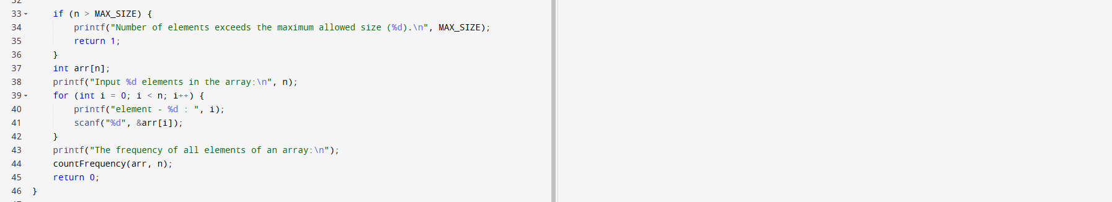

80. Write a C program that accepts a string and reverse it using a stack. > Expected Output: Input a string: w3resource Reversed string using a stack is: ecruoser3w.

